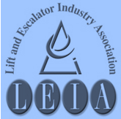

S

The Lift & Escalator Industry Association
SAFETY Matters
January 2013

Tel: 020 7935 3013
Fax: 020 7935 3321
Email: enquiries@leia.co.uk

Contents
- Winter Driving
- No Smoking Day
- Safe Use of Shorting Wires
- ‘Hard and Fast’ Mini-Vinnie
- Safety Charter training talks
Introduction
Welcome to the January 2013 edition of Safety Matters.
Through this newsletter our aim is to inform you of health and safety issues that may have an impact on the lift and escalator industry. Safety Matters is also available for download from the LEIA member’s website. www.leia.co.uk

Driving in the Snow and Ice
Don’t be fooled into thinking that the recent snowfall is all you are likely to get this winter. Snow fell on 6th June in Scotland in 2009.
This is what the Institute of Advanced Motorists recommends:

When driving in snow, get your speed right - not too fast that you risk losing control, but not so slow that you risk losing momentum when you need it - and brake, steer and accelerate as smoothly as possible.
Start gently from stationary, avoiding high revs. If you get yourself into a skid the main thing to remember is to take your foot off the pedals and steer. Only use the brake if you cannot steer out of trouble.
Double or triple your normal stopping distance from the vehicle in front. Drive so that you do not rely on your brakes to be able to stop - on an icy surface they may simply not do that for you!
If your vehicle has ABS in very slippery conditions it will not give you the same control in others. Do not rely on it.

Plan your journey around busier roads as they are more likely to have been gritted. Avoid using shortcuts on minor roads - they are less likely to be cleared or treated with salt, especially country lanes.
On motorways stay in the clearest lane where possible, away from slush and ice.

Keep within the clear tyre tracks if you can.
Stay in a higher gear for better control, and if it is slippery, in a manual car move off in a higher gear, rather than just using first.
On a downhill slope get your speed low before you start the descent, and do not let it build up - it is much easier to keep it low than to try to slow down once thing get slippery; in falling snow used dipped headlights or fog lights to make yourself visible to others (especially pedestrians) - but as conditions improve make sure your fog lights are only on if necessary as they can dazzle other drivers.
If you are following another vehicle at night, using their lights to see ahead can cause you to drive dangerously close - keep well back from other traffic.

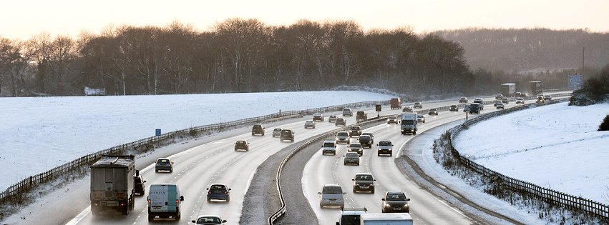

Highways Agency

Mental Health
This year’s No Smoking Day is on Wednesday, 13th March and this year’s theme is ‘Swap your Fags for Swag. Bin the fags for a week and take the kids to the cinema on the proceeds.
NO SMOKING DAY 2013
When questioned, focus groups gave saving money as one of the big drivers for stopping smoking. The British Heart Foundation is using that idea to promote No Smoking Day.
Stopping smoking now could be like giving yourself a hefty pay rise – and it’s one benefit you’ll feel straight away.
For a 20-a-day smoker...
1 day: £7 = two movie rentals, download a new album
1 week: £49 = a family cinema trip, a pair of shoes, a meal for two
1 month: £210 = a shopping spree, premiership football tickets
3 months: £630 = a new laptop, the latest flat screen TV
6 months: £1,260 = a leather suite, a home cinema, a top of the range bicycle
1 year: £2,555 = a new kitchen, designer jewellery, the holiday of a lifetime
For help with quitting, see the No Smoking Day website:
http://www.nosmokingday.org.uk
After reports of a fatality in Shanghai of a member of the public falling to their death because shorting wires left in place caused the landing doors to remain open, whilst the car was moving, it is a good time to restate the advised use of these useful pieces of kit.
SAFE USE OF SHORTING WIRES
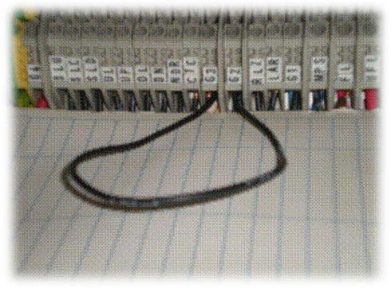
The use of shorting wires to bypass parts of circuits, particularly stop circuits, needs to be controlled and most companies now have very strict procedures in place to cover this, with many specifying long wires of distinct colours to avoid the danger created by shorting wires being inadvertently forgotten and left in place.
For this reason, the use of “homemade” shorting wires, made up on site, in an uncontrolled way is outlawed by many companies. You should always follow the procedure laid down by your employer and in cases of doubt refer to your supervisor. The picture shows a temporary shorting wire which was inadvertently left in place.

Vinnie returns - and this time he's got a pint-sized pal!
HARD and FAST NEW
MINI-VINNIE
The BHF new Hands-only CPR campaign features a new online training film, this time starring Mini Vinnie and his mini henchmen.
So let Mini Vinnie teach you a lesson you'll never forget.
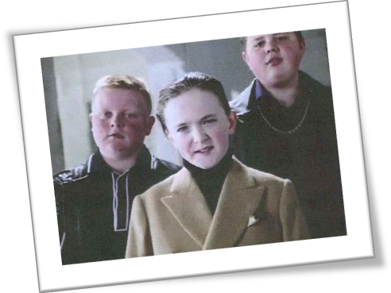
If someone has collapsed, is not breathing normally and is not responsive to shaking and shouting then Hands-only CPR can increase their chances of survival prior to a defibrillator and professional help arriving.
Calling 999 and pushing hard and fast in the centre of their chest to the beat of Stayin' Alive by the Bee Gees until an ambulance arrives could help save their life.
It’s been shown that chest compressions are often carried out at the wrong depth and speed so ‘hard and fast’ is a very simple message that lots of people will hopefully remember. ‘Hard’ means pushing on the chest to a depth of 5cm to 6cm, and ‘fast’ means 100-120 compressions a minute, roughly the same speed as Stayin’ Alive by the Bee Gees.
At the moment, less than 10 per cent of the 30,000 people in the UK who have a cardiac arrest out of hospital each year survive long enough to leave hospital alive. If someone carries out early CPR, it may double a casualty’s chances of survival. Hands-only CPR should increase the number of bystander interventions and save lives.
http://thebritishheartfoundation.chtah.com/a/hBQq38pB8XP6RB8unW4AACGMJCI/haw18#&panel1-4
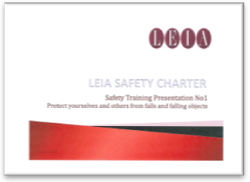
The three Safety Training Presentations were launched late last year. These new toolbox talk-type presentations cover the three major hazard areas highlighted in the LEIA Safety Charter:
SAFETY CHARTER - SAFETY TRAINING PRESENTATIONS
- Protect yourselves and others from falls and falling objects
- Use and verify Stop and other devices when accessing, egressing and working on car tops and in lift and escalator pits to ensure total control of the equipment
- Electrically isolate and lock off when power is not required and when working close to unguarded machinery
The presentations are aimed at the workforce to show best practice. They are free to download from the LEIA website, on the public-facing home page to make them as accessible as possible.

